**Merge Two Sorted Lists**

Merge two sorted linked lists and return it as a **sorted** list. The list should be made by splicing together the nodes of the first two lists.

**Example 1:**

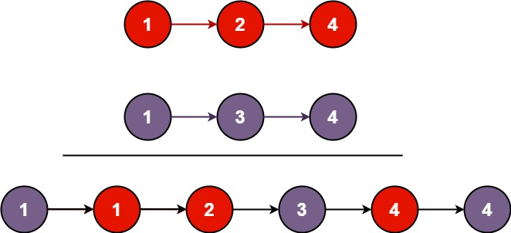

**Input:** l1 = [1,2,4], l2 = [1,3,4]

**Output:** [1,1,2,3,4,4]

**Example 2:**

**Input:** l1 = [], l2 = []

**Output:** []

**Example 3:**

**Input:** l1 = [], l2 = [0]

**Output:** [0]

**Constraints:**

* The number of nodes in both lists is in the range [0, 50].
* -100 <= Node.val <= 100
* Both l1 and l2 are sorted in **non-decreasing** order.